**Mapping Cropland Use Dynamics for the Decision Support System for Nuclear Emergencies Affecting Food and Agriculture (DSS4NAFA)**

**Liu Yuan1, Lazar Adjigogov2, Franck Albinet2, Gerd Dercon2, Yu Qiangyi1※, Wu Wenbin1, Zhou Qingbo3**

(1. Institute of Agricultural Resources and Regional Planning, Chinese Academy of Agricultural Sciences /Key Laboratory of Agri-Informatics, Ministry of Agriculture, Beijing 100081, China; 2 Soil and Water Management & Crop Nutrition Laboratory, Joint FAO/IAEA Division of Nuclear Techniques in Food and Agriculture, Seibersdorf A-2444, Austria.; 3. Agricultural Information Institute, Chinese Academy of Agricultural Sciences, Beijing 100081, China)

**Abstract**: **[Purpose]** We applied cropland use maps to the Decision Support System for Nuclear Emergencies Affecting Food and Agriculture (DSS4NAFA), to demonstrate the application and significance of remote sensing based crop mapping in DSS4NAFA. **[Method]** Taking Daya Bay nuclear power base as a case study, we first mapped the cropland use dynamics in its surrounding areas by identifying crop rotation systems. A decision rules based model was used to identify the crop rotation systems combining Sentinel-1Synthetic Aperture Radar and Sentinel-2 MultiSpectral satellite images. Then the cropland use maps were post-processed and uploaded to DSS4NAFA, based on which we realized the automatic assignment of crop sampling task and simulation of spatiotemporal distribution of radionuclide concentration. **[Result]** The proposed decision rules based model could be used to produce accurate and dynamic cropland use maps in areas with fragmented cropland and dense clouds. Spatially, the central region is dominated by vegetable and paddy systems, while the eastern region is mainly paddy and orchard systems. And vegetable systems are widely distributed in the western region. The cropland use maps post-processed can be easily applied to DSS4NAFA, and thereby assist in the automatic assignment of crop sample points, and the simulation of spatiotemporal distribution of radionuclide concentration. **[Conclusion]** The combination of remote sensing based crop mapping and DSS4NAFA further improves the effectiveness of sampling task assignment and spatiotemporal radionuclide concentration simulation. Thus it could help decision-makers draw up plans for nuclear pollution monitoring, evaluation, and remediation, and guide the recovery of agricultural production. In the future, it is necessary to deeply study the application of remote sensing based crop mapping in DSS4NAFA, and make full use of the advantages of remote sensing technology and data, avoiding the risk of nuclear accident to agricultural production.

**Key words:** Daya Bay nuclear power station; Nuclear accident; Guangdong; Google Earth Engine; Sentinel data­

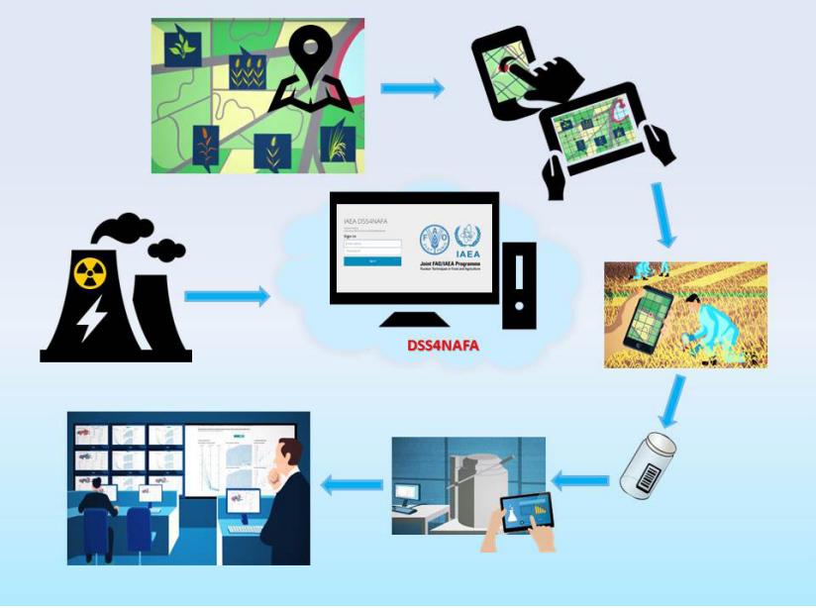

Fig.1 Sketch map of the Decision Support System for Nuclear Emergencies Affecting Food and Agriculture (Source：https://www.iaea.org/）

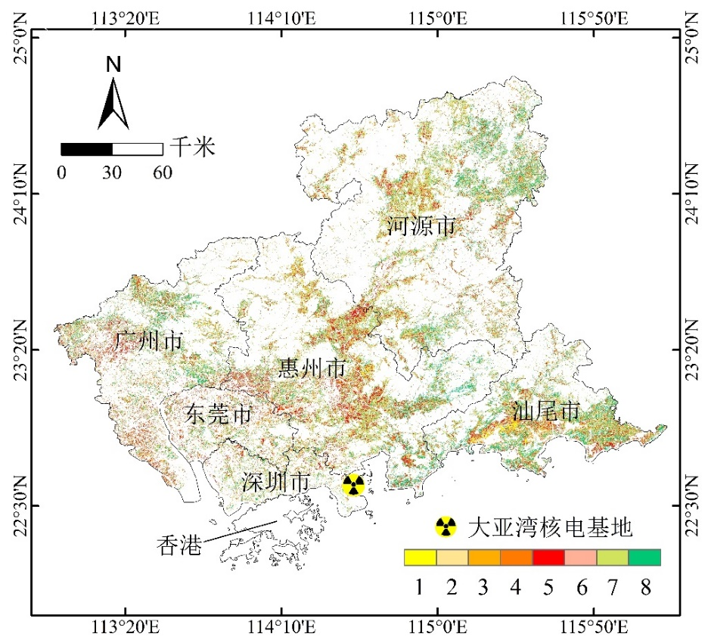

Fig.4 Crop rotation system map in 2020

Notes: Number 1~8 represent: 1. double rice; 2. double rice rotated with vegetables; 3. single rice; 4. single rice rotated with vegetables; 5. leafy vegetables; 6. non-leafy vegetables; 7. short growing cycle orchard; 8. long growing cycle orchard.

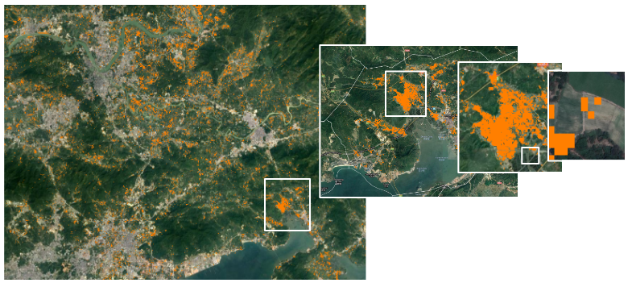

Fig.5 Pruning isolated pixels in raster crop rotation map

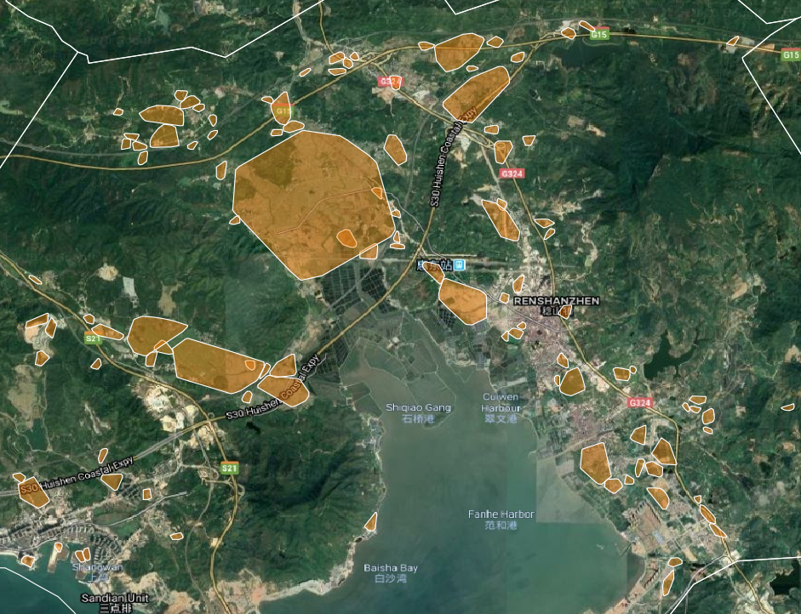

Fig.6 Simplifying the geometry of agricultural fields to ease communication and decision-making

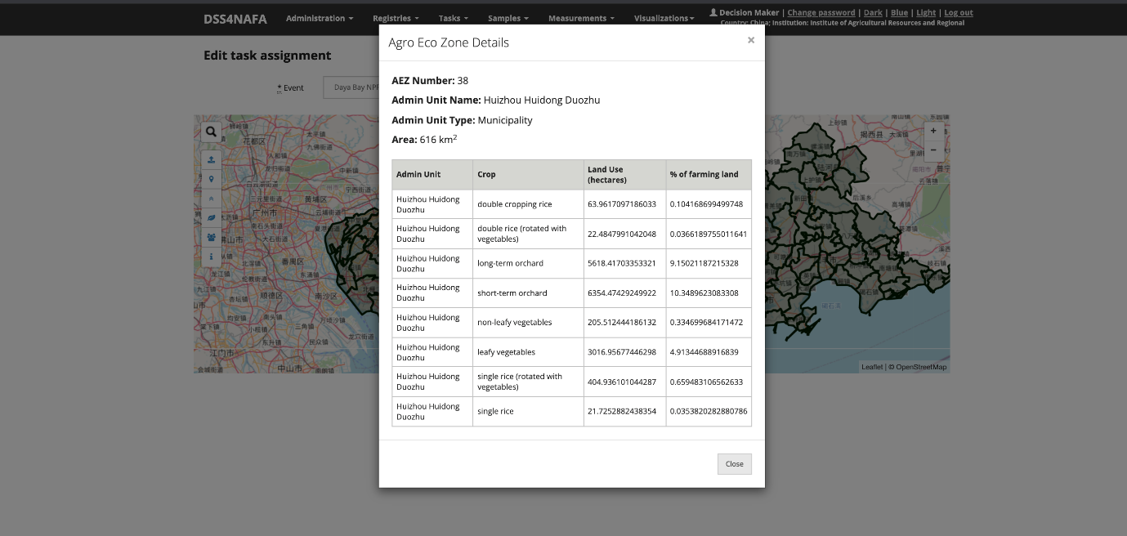

Fig.7 Calculating land use, i.e., crop farming land percentage (%) and size (hm2) for each predefined crop rotation system in different regions

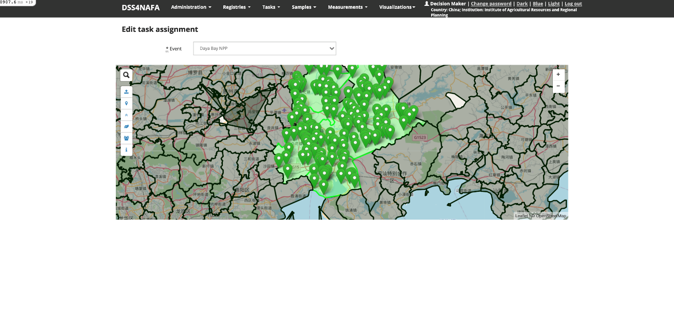

Fig.8 Automatically generating random crop sample points in a specific area

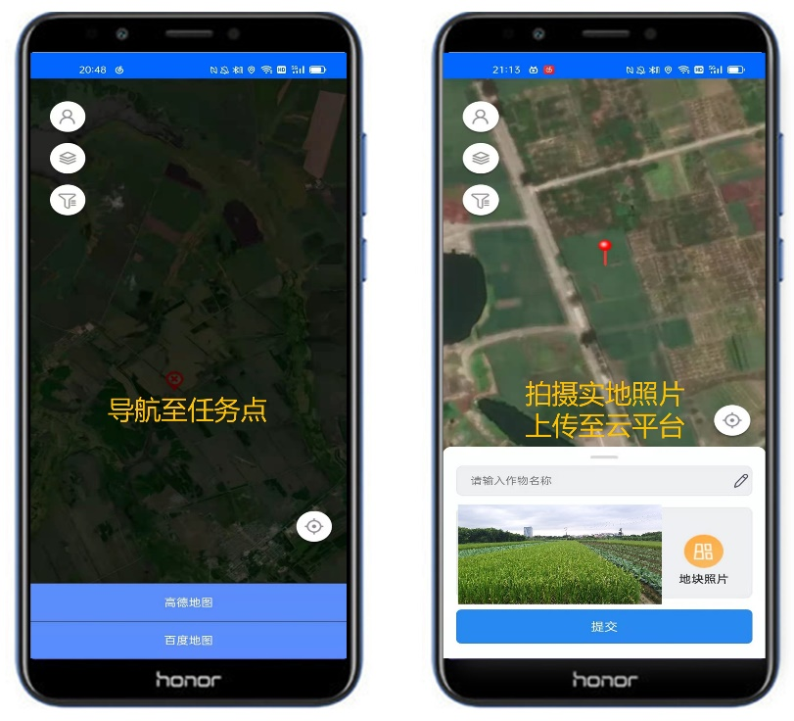

Fig.9 Collection of sampling task points

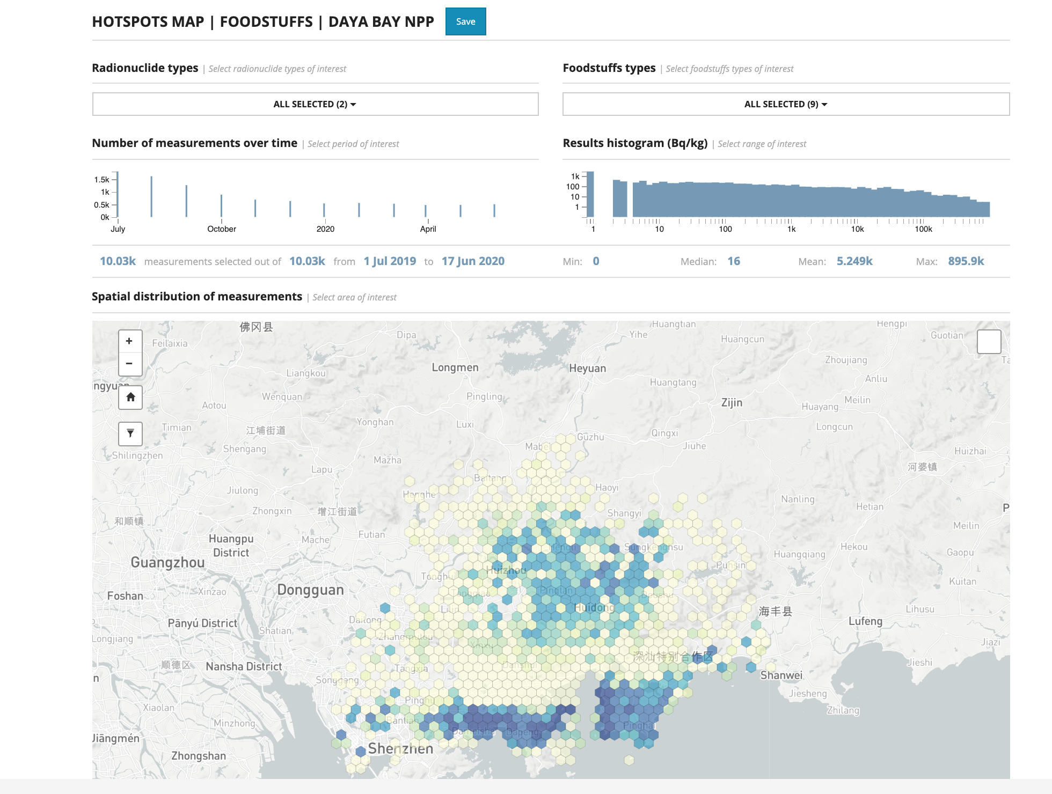

Fig.10 Simulation of spatiotemporal distribution of radionuclide concentration